“M&M” INCUBATORS OF
TERROR

It is not about the pervasive M & M Chocolate Easter bunny that Christian households across North America and several Western countries indulge nor is anything to do with holy festivities, unlikely to be associated with terrorism or something close to it.
When a highly-motivated group of young Eritreans, organized by YPFDJ, were gathering for an annual conference from across Europe with a youthful fervour and a sense of duty to themselves, their respective communities and the motherland, they came across an unpleasant surprise stashed in an Easter basket, not of the M & M chocolate bunny, but of an organized intimidation, packaged with “human rights” glossy wrap, by non-other than Mirjam Van Vizen and Martin Plaut. These two notoriously anti-Eritrea individuals, like the crowds during the trail of Jesus, keep howling for the crucifixion of Eritrea.
In the Diaspora, the unravelling events around the conference had for a while weighed in the otherwise jovial celebrations of the national holiday. In a special EriTV program where Helen Melles was interviewed, most of her patriotic songs, which gained popularity at the helm of the instigated 1998 “border” war, came rolling one after the other. At the top of all was the one titled “Warsay” ---a symbolic term used to describe the Eritrean youth, who like the generation before them, heroically defended and aborted a foreign aggression during the invasion in 1998. One of the conspicuous lines in the song poses a pointed question: “Who are they?” “Who are they?” Likewise, the youngsters among the attendees of the conference who were caught by surprise, may have asked “Who are these zombies?”.
Well, two decades into the foreign instigated conflict, Eritreans and, to some extent, some friends and sympathizers to our cause, have been exposing the hostile role of certain groups and individuals who served or have been serving as select operatives of the anti-Eritrea enterprise run by powerful entities.
Obviously, the same question also applies to these two individuals, one nominally a journalist and the other a human rights expert. Who the hell are these two zombies: Mijriam Van Vencent and Martin Plaut? Despite the waning credibility of the anti Eritrea groups, long masquerading as concerned human rights activists and what not, “M & M” seem to be among the few still plodding on in the service of their now frustrated sponsors who are anxiously witnessing their flagship mercenary state, in a state of emergency. By contrast, Eritrea turned the table and has started to outshine the dark clouds of vilification, again asserting itself as a key player of peace and stability in our region.
As much as exposing these two operatives continues, it may also be timely to ponder for how long are Diaspora Eritreans continuing to tolerate these zombies, instead, start to be proactive and take appropriate measures to stop them.
After the military option to subdue Eritrea failed, the architects of anti-Eritrea hostilities have been using various means, one of which was to demonize and isolate the Eritrean government/EPLF, not only from the international community, but also to break its organic ties with the Diaspora communities across the globe. Their harassments continued from openly sending a police raid to expropriate funds in a community center in Washington DC to targeting remittances and then the 2% rehabilitation tax. On another front, they set out to create parallel Eritrean associations to eventually replace the various mass associations that have laid their roots starting from the days of independence struggle. In this regard, their prime target has been the youth. Such hostile scheme was clearly laid out in WikiLeaks: a dispatch in 2009 of the US ambassador in Eritrea, Ronald K. McMullen,
<<
…Give the youth an alternate voice. As of now, the YPFDJ is the primary outlet for young Eritreans in the diaspora to express pride in their culture. Currently, there is no non-EDA aligned counter to the YPFDJ…
>>
http://www.aftenposten.no/norge/14122009-ENGAGING-THE-ERITREAN-DIASPORA-183087b.html

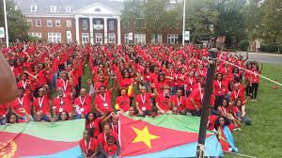

It was a year into the dispatch of such directives from the then US ambassador, that a spate of hooligans mushroomed in several European and American cities, almost two years before the Diaspora Eritreans took the necessary steps to put them back into their place. The TPLF subcontractors of mayhem in the Horn have been behind those harassments; to name a few of those incidents: the firebombing of the Eritrean Community centers in Sweden, the damaging of the Community Center in Oakland and the harassment of women and children participating in festivals and the violent attack of women in Frankfurt.
It is in line with that master plan that “M & M” have pulled their latest stunt to conspire against the YPFDJ conference. In her FB profile, her atrocious demeanor is highlighted by a “No Fear” tag. Short of trying to psychoanalyse her FB profile, one can assume that the “No Fear” slogan may be either a message directed to her followers who seem to see her as a mother figure--- albeit a mother of hooligans ---and/or as a self uplifting tool from her worries of a possible response by the organized Eritrean Community, especially YPFDJ, from unleashing new energies, typical of the Eritrean response when pushed beyond the red line.
The first assumption has proven true, though it did not achieve its objectives; indeed, she and her close associates managed to organize a well executed act of hooliganism and caused some disruption to the scheduled activities of the Conference.
Her expectation could have not been less than instigating a response in kind from the YPFDJ youth, start a mayhem all under the watchful eyes of curiously waiting crew from various Dutch TV stations and police; thus, build an incriminating case not only against the YPFDJ, but also against the activities of Diaspora Eritreans public assemblies and festivals in the Netherlands and beyond.
Well, the outcome was grossly short of their expectation. Despite the provocative acts of the “M & M” hooligans, the attendees stayed in the hotel doing about their business until they were instructed, under the unfair ruling of the town kangaroo court, to leave the hotel premises. They left in an orderly way to stay the rest of the night hosted by Eritrean Dutch residents; and with typical resourcefulness and flexibility of Eritreans, a national character that was sharpened during the long-armed struggle, they managed to continue the conference in three various locations and successfully completed their set agenda, with the only difference that they postponed for the next conference the usual bombastic concluding party they use to throw together with joy and comradery.
That is when the real fear of Mijriam Van Vencent starts for real. She had already experienced a bold challenge from a young Eritrean, Messeret Bahlibi who singlehandedly filed a law suite against her, last year. Though, the ruling went in her favor, it set a precedent and had signaled in what direction and to what extent an organized and resourceful organization like YPDJ can go to challenge and eventually put her and her likes in their place.

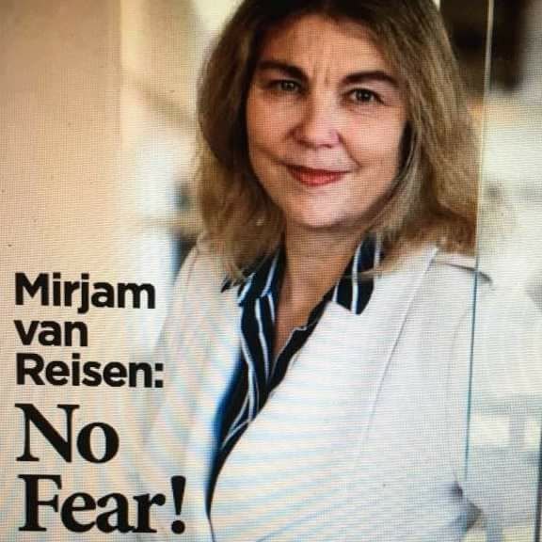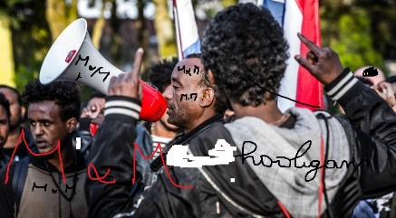

The silver lining that came out of this hostility is that the well disciplined and law abiding YPFDJ conference attendees, have instead built a case against the hooligans, their mentors and those who ruled against their rights of assembly.

With a pretentious bravado, “No Fear”, and the tweets of Martin Plaut echoing her tweets, they kept reinforcing their conspiratorial messages as events unfold, until the moment came when they tried to cover up their failure with a distorted news, claiming that the Dutch government has summoned the Eritrean government representative. That was what they conspired and wished for: instigate a violent row, broadcast the ensued row live on Dutch national media outlets, have the police arrest those involved in the fight, all providing evidence to the authorities to take punitive action that impacts not only the YPFDJ, but also the Eritrean government and all related Diaspora activities.
Though on a different scale, Martin Plaut has been left to suffer by yet another disappointment. He was the one along other subcontractors of Fake News and Fake Reports, in this case against Eritrea, who announced on Jan 24, 2014 on a coup in Asmara that did not take place. So, out of frustration, like his new book reveals (bewildered why the Eritrean government/ EPLF has not collapsed yet) he can’t help it but try to console/delude himself with an imaginary event where the Eritrean government is starred down by the Dutch government and be at the receiving end of some punitive action and what not.
In fact, it was the Eritrean government that requested a meeting with the Dutch authorities
After watching these subcontractors of Fake news and Fake reports for many years, it is about time that more should be done beyond exposing them. There is much evidence in our hands to challenge them in the court of law. To mention one such salient instance, in July 2015, in Monocle radio where Martin Plaut is regularly invited as Africa expert, he made an astounding statement, way beyond his usual diatribe and distortions. Doubling down on false claims by another guest presented as an Eritrean human rights activist, without mincing words, he called for an extreme violence against the Eritrean head of state!! (click around the 25-min. mark)
https://monocle.com/radio/shows/the-foreign-desk/74/

“M & M”, the two subcontractors of Fake news and Fake reports against Eritrea, tried to trigger chaos within the Eritrean Diaspora, a projection of their ugly hallucination on the EPLF, the Eritrean government and the Eritrean Defence Forces; “M&M” and their associates have for long been wishing and working to see a rampant criminality and violence within our Diaspora communities. With a veil of journalism and human rights activism, they have been encouraging violence; as such, they are essentially incubators of terror. They would do whatever it takes to instigate violence within the Eritrean communities, an evil act that they failed to see like many of their associates, for the simple reason that they have no idea about the social fabric of Eritreans. However, as in many cases, the Eritrean way of facing adversity with civility may be interpreted otherwise; that is why Eritreans across the board are calling to take all necessary measures, shift gear and be proactive within the bounds of law.
As Eritreans in the Diaspora are gearing up their Mekete activities (defence of the motherland) certain points are worth stressing based on the direction that the anti Eritrea quarters may be trying to take in their attempts to disrupt and delegitimize our activities. If they failed to realize their objective in the last YPFDJ conference, it doesn’t mean they will stop there. YPFDJ has already taken measures and more initiatives are also expected to challenge the injustices that they experienced from the concerned Dutch authorities.

An activist mother pitching in with some local chapter members of NUEWn (National Union of Eritrean Women) described the reactions of some youngsters who came for the first time to attend the conference. HEDRI wing—youth between the ages 13 to 15—has been a new entry into the annual YPFDJ conference. Before, the activist mother, with a typical reassuring tone of Eritrean mothers, explained to them what was going on, some were visibly angry and some were getting close to tearing up, as they struggled to figure out all the unexpected scene created by the “M & M” hooligans. Though that was their initial response, after all came to pass, and after watching how in a civilized way the adversity was handled, inadvertently, they got more than they would have learned from several seminars all put together. Above all, they got empowered as their elder fellow participants faced all the harassment with civility and resourcefulness.
Before Europe was inundated with refugees and the ongoing threat of extreme violence from foreign inspired youth who are born and raised in Europe, several programs have been introduced, all geared towards the integration of marginalized second and third generation children of immigrants. The challenges of integration had been manifesting itself in several EU nations like France and Britain.
Now, the question that must be posed is how does the hostilities and subterfuge by “M& M” and associates fare in terms of the challenges of integration and deradicalization that Europe is facing?
http://icsr.info/wp-content/uploads/2012/12/ICSR-Report-Countering-Radicalization-in-Europe.pdf

Let’s forget for a moment the ideological aspects of the YPFDJ movement, but try to see it as an organization where highly motivated youth of all ages and education levels, a significant member of whom also leading a successful life, are targeted and vilified, while hooligans are encouraged under a misguided or calculated protective mechanisms provided by certain segments of the authorities who have connections with the likes of “M & M” incubators of terror and their sponsoring agencies.
If we see such injustices from the point of view of the uninitiated youngsters, aspiring or active members of YPFDJ who are born and raised in Europe, what they saw was a flagrant disregard of their basic rights that they take for granted as full fledged citizens. To the contrary, what they experienced was a state that was supposed to protect those who abide by the law would not guarantee their safety even when faced with a handful of hooligans or that the freedom of assembly is selectively given to a select few who can call at any moment an armada of anti-protest squads against those who speak out against injustices.

Clearly, from whichever angle one tries to see, the hostile acts of “M & M” incubators of terror, does not only contradict the objectives of integration and deradicalization that several European nations are haphazardly struggling to devise and implement, but it also defeats the purposes of such projects and programs.

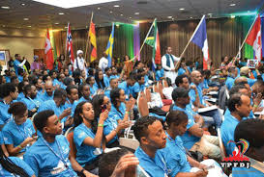

In a karmic turn of events, some European nations, including major EU nations, have started to engage Eritrea on the refugee crisis. As part and parcel of the anti Eritrea conspiracies, the pull factor that the European states had been dissuaded to facilitate, mainly targeting Eritrean youth, Europe has been receiving thousands of “Eritrean” refugees. Well, it is left to the host nations to find out the thousands from other African nations who settled in Europe under bogus Eritrean identity.
In this regard, one thing must be clear; except for few quarters, we can say that with the increasing refugee crisis, Europeans from different walks of life including those placed in high echelons of power, have started to appreciate more than ever that someone had pulled a wool over their eyes not to see Eritrea as a reliable partner of peace and stability in the Horn.
As Europe is opening to engage Eritrea, obviously, the Diaspora communities have at this moment a role to play in key area that is of high priority to European governments. So, our MeKete should aggressively focus our outreach endeavours to concerned authorities and grass roots organizations by presenting our organizational assets like YPFDJ and NUEWn. Among other things, YPFDJ, in one form or the other, not only includes some key aspects of the objectives of various programs of integration run by EU nations, it also has solid foundation to thrive and serve as a model to various other ethnic communities in the Diaspora.
As was pointed out earlier, Eritrea has turned the table and its outreach, both through official and public diplomacy, has been getting more traction. The incident of last month around the YPFDJ conference has, to the advantage of MeKete, provided opportunities on two fronts; while exploring the legal front, on the political side, concerned European authorities, groups and individuals can be educated to see the difference between two diametrically opposite options: engaging a solid community based organization with organic ties to the homeland that cultivates and empowers youth on one side and others who for myopic self serving objectives exploit deranged youth into acts of hooliganism and violence and more violence.

Awet nHafash!
Haileab Luul Tesfai
14-5-17

